Jeremy Barthélemy  
ECE 746  
Hw. 2

1. Find all irreducible polynomials:

(a) of degree 4 over *GF*(2),  
From the textbook: “A polynomial f(x) over a field F is called irreducible if and only if f(x) cannot be expressed as a product of two polynomials both over F, and both of degree lower than that of f(x).”  
We can determine whether the polynomials are irreducible by performing the test A(x) mod m(x) = 0? If it is equal to 0, then it is not an irreducible polynomial. If this is not the case, we can test various other irreducible polynomials m(x) of lower degree to further determine whether or not A(x) is reducible. If none of them successfully reduce A(x), we know that A(x) is an irreducible polynomial.   
We can test with x, x + 1, x2 + x + 1, x3 + x + 1, x3 + x2 + 1

Below is a list of all monic polynomials of degree 4, along with their respective binary representations for simpler calculation.

|  |  |
| --- | --- |
| Polynomial | Binary Rep. |
| x4 + x3 + x2 + x + 1 | 11111 |
| x4 + x3 + x2 + x | 11110 |
| x4 + x3 + x2 + 1 | 11101 |
| x4 + x3 + x2 | 11100 |
| x4 + x3 + x + 1 | 11011 |
| x4 + x3 + x | 11010 |
| x4 + x3 + 1 | 11001 |
| x4 + x3 | 11000 |
| x4 + x2 + x + 1 | 10111 |
| x4 + x2 + x | 10110 |
| x4 + x2 + 1 | 10101 |
| x4 + x2 | 10100 |
| x4 + x + 1 | 10011 |
| x4 + x | 10010 |
| x4 + 1 | 10001 |
| x4 | 10000 |

Example test:  
11111  
11000  
00111  
00110  
00001  
Not divisible by x+1, now test with x:  
11111  
10000  
01111  
01000  
00111  
00100  
00011  
00010  
00001  
Again, we find that the result is not 0, thus x4 + x3 + x2 + x + 1 is our first irreducible polynomial.  
  
If we test x4 + x3 + x2 + x, however, we can easily see that it is divisible by x:  
11110  
10000  
01110  
01000  
00110  
00100  
00010  
00010  
00000

I found the following to be another irreducible polynomial by simple inspection: x4 + x + 1  
To verify:  
10011  
11000  
01011  
01100  
00111  
00110  
00001  
  
And if we perform the modulus operation using x:  
10011  
10000  
00011  
00010  
00001  
  
Finally, I found one more irreducible polynomial for this case: x4 + x3 + 1 (11001)  
11001  
10000  
01001  
01000  
00001  
  
And by using x+1,  
11001  
11000  
00001  
So, I found the following three irreducible polynomials, which were not reducible under (00010, 00011, 00111, 01011, 01101)2 polynomials:  
x4 + x3 + x2 + x + 1, x4 + x + 1, and x4 + x3 + 1  
  
b) of degree 2 over *GF*(3).  
Below is a list of all monic polynomials of degree 2 over GF(3):

|  |  |
| --- | --- |
| Polynomial | Ternary Rep. |
| x2 + 2x + 2 | 122 |
| x2 + 2x + 1 | 121 |
| x2 + 2x | 120 |
| x2 + x + 2 | 112 |
| x2 + x + 1 | 111 |
| x2 + x | 110 |
| x2 + 2 | 102 |
| x2 + 1 | 101 |
| x2 | 100 |

Testing x2 + 2x + 2:  
122  
100  
022  
010  
012  
  
122  
110  
012  
011  
001  
  
We find that x2 + 2x + 2 is an irreducible polynomial.  
Testing x2 + 2x + 1:  
121  
100  
021  
010  
011  
010  
001  
  
121  
110  
011  
011  
000  
x2 + 2x + 1 is a reducible polynomial.  
  
Testing 120:  
120  
100  
020  
010  
000  
Clearly, this is x2 + 2x is also a reducible polynomial.  
  
Along with x2 + 2x + 2, I found two other irreducible polynomials: x2 + 1 and x2 + x + 2.  
Example:  
112  
110  
002  
  
112  
100  
012  
010  
002  
2.(a) One attack I was able to find was here: http://www.iacr.org/cryptodb/archive/2004/PKC/3421/3421.pdf, where the greatest field size to be successfully attacked was of GF(263), although another claims that the best is over GF(2503)! http://www.rsa.com/rsalabs/node.asp?id=2194

(b) Although some rather large attacks have been mounted successfully (the largest public one being of GF(297), it is generally considered secure in the range from GF(232) to GF(2128), depending upon what purpose and how important the protection is.  
http://www.rsa.com/rsalabs/staff/bios/aoprea/publications/GF.pdf

(c) Yes, as it is becoming increasingly important to perform these operations quickly in a cryptographic perspective, there are many new and upcoming algorithms to improve upon the speed. For example, the algorithm presented here; http://www.princeton.edu/~rblee/ELE572Papers/Fall04Readings/NingYin-FiniteFieldMul.pdf, which claims to offer a more efficient solution to software implementations of finite field multiplication.  
3.

We generate the alog and log tables by taking a generator for this case to produce the values:  
Taking 2 or (10)2 and squaring mod P(x), we find the following values:  
10 mod 11001 = 00010  
10*10 mod 11001 = 00100  
10*100 mod 11001 = 01000  
10*1000 mod 11001 = 01001  
10*1001 mod 11001 = 01011  
10*1011 mod 11001 = 01111  
10*1111 mod 11001 = 00111  
10*111 mod 11001 = 01110  
10*1110 mod 11001 = 00101  
10*101 mod 11001 = 01010  
10*1010 mod 11001 = 01101  
10*1101 mod 11001 = 00011  
10*11 mod 11001 = 00110  
10*110 mod 11001 = 01100  
10*1100 mod 11001 = 00001  
  
Thus, the tables are as follows:

|  |  |
| --- | --- |
| k | alog(k) |
| 1 | 10 |
| 10 | 100 |
| 11 | 1000 |
| 100 | 1001 |
| 101 | 1011 |
| 110 | 1111 |
| 111 | 111 |
| 1000 | 1110 |
| 1001 | 101 |
| 1010 | 1010 |
| 1011 | 1101 |
| 1100 | 11 |
| 1101 | 110 |
| 1110 | 1100 |
| 1111 | 1 |

|  |  |
| --- | --- |
| k | log(k) |
| 1 | 1111 |
| 10 | 1 |
| 11 | 1100 |
| 100 | 10 |
| 101 | 1001 |
| 110 | 1101 |
| 111 | 111 |
| 1000 | 11 |
| 1001 | 100 |
| 1010 | 1010 |
| 1011 | 101 |
| 1100 | 1110 |
| 1101 | 1011 |
| 1110 | 1000 |
| 1111 | 110 |

(a) A * 7 = 10*7 = 1010 * 0111  
= alog[log[1010]+log[0111] mod 10000]  
= alog[1010 + 111 mod 10000]  
= alog[10001 mod 10000] = alog[1] = 10 = 2

(b) 5*F = 5*15 = 0101 * 1111  
= alog[log[0101] + log[1111] mod 10000] = alog[1001 + 110 mod 10000] = alog[1111] = 1

(c) B-1 = 11-1 =   
We calculate this first by determining the inverse of B:  
x*B-1 mod n = 1  
alog[log[1011] + log[x] mod 10000] = 1 🡪B-1 = 1010, so to verify, 1010*1011 🡪   
alog[log[1010] + log[1011] mod 10000] 🡪 alog[1010 + 101 mod 10000] = 1

(d) C * D-1 = 12 * 13-1alog[log[1101] + log[x] mod 10000] = 1  
1011 + log[x] mod 10000 = 1111  
log[x] mod 10000 = 100  
x = 100, so 🡪D-1 = 100 🡪 alog[log[1100] + log[100] mod 10000] 🡪  
alog[1110 + 10 mod 10000] = 104.

(a) de Fermat Little Algorithm:  
To determine the inverse of A(x), we use A(2^m)-2 mod P(x).  
Thus, with m = 4, we need to calculate A(x)14.  
A(x) = x + 1  
A(x)2 = x2 + 1  
Then multiplying by A(x) again, we obtain  
A(x)3 = x3 + x2 + x + 1  
A(x)6 = x3 + x, which we square to obtain  
A(x)12 = x3  
Then with A(x)12 * A(x)2, we obtain A(x)14 = x3 + x2 + x.  
To verify that this is indeed the inverse of A(x), we test it:  
1110 * 0011 = 10010  
10010  
10011  
00001  
Thus, the inverse is x3 + x2 + x

(b) Extended Euclidean Algorithm for Polynomials:

|  |  |  |  |
| --- | --- | --- | --- |
| i | qi | ri | xi |
| -2 | - | 10011 | 0 |
| -1 | 1110 | 11 | 1 |
| 0 | 11 | 1 | 1110 |
| 1 | - | 0 |  |

Where we can see that 1110 = x3 + x2 + x, which is the same result as obtained using Fermat’s Little Theorem.  
5.  
a.  
i qi ri xi

-2 - x^7 + x + 1 0

-1 x^6 + x^5 + x^4 + x^3 + x^2 + x x + 1 1

0 - x^6 + x^5 + x^4 + x^3 + x^2 + x

('Result: ', x^6 + x^5 + x^4 + x^3 + x^2 + x)

b.

|  |  |
| --- | --- |
|  | i qi ri xi  -2 - x^5 + 2*x + 1 0  -1 2*x^3 + 2*x 2*x^2 + 1 1  0 - x^3 + x  ('Result: ', x^3 + x) |

Sage:  
P.<x> = GF(3^5,'z')[]

def Problem5(Px, Ax):

(A1, A2, A3) = (1, 0, Px);

(B1, B2, B3) = (0, 1, Ax);

print'i', ' qi ri xi';

i = -2;

print i, ' ', '-', ' ', A3, ' ', A2;

i = i + 1;

qi = A3.quo_rem(B3)[0];

print i, ' ', qi, ' ', B3, ' ', B2;

Qtemp = 0;

while(True):

i = i + 1;

if(0 ==B3.degree()):

return('Result: ', B2/B3);

Qi = A3.quo_rem(B3)[0];

(T1, T2, T3) = (A1 - qi*B1, A2-qi*B2, A3 - qi*B3);

if(Qtemp == 0):

print i, ' ','-', ' ', T2;

if(Qtemp != 0):

print i, ' ',Qtemp, ' ', T2;

Qtemp = qi;

(A1, A2, A3) = (B1, B2, B3);

(B1, B2, B3) = (T1, T2, T3);  
#Followed by the line below in a different code line to test:  
Problem5(x^7+x+1, x+1)

6.  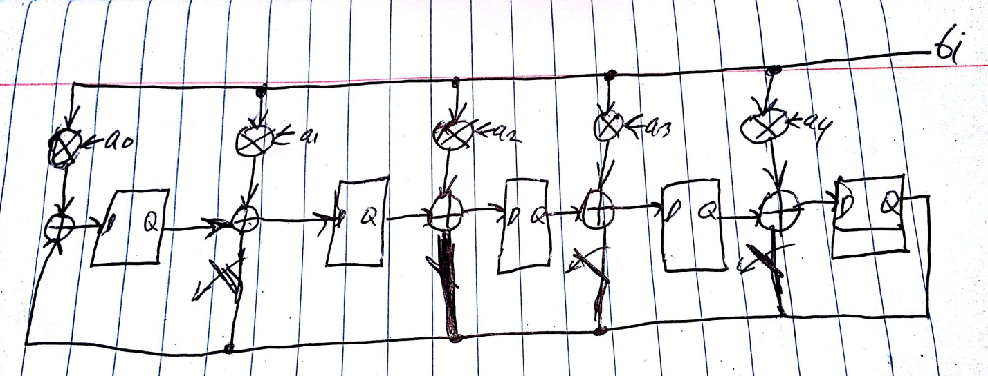

7.

(a) We have C(x) = A(x)B(x) mod P(x)  
c1x + c0 = (a1x + a0)(b1x + b0) mod x2 + p1x + p0 =  
a1b1x2 + a0b1x + b0a1x + a0b0 mod x2 + p1x + p0 = 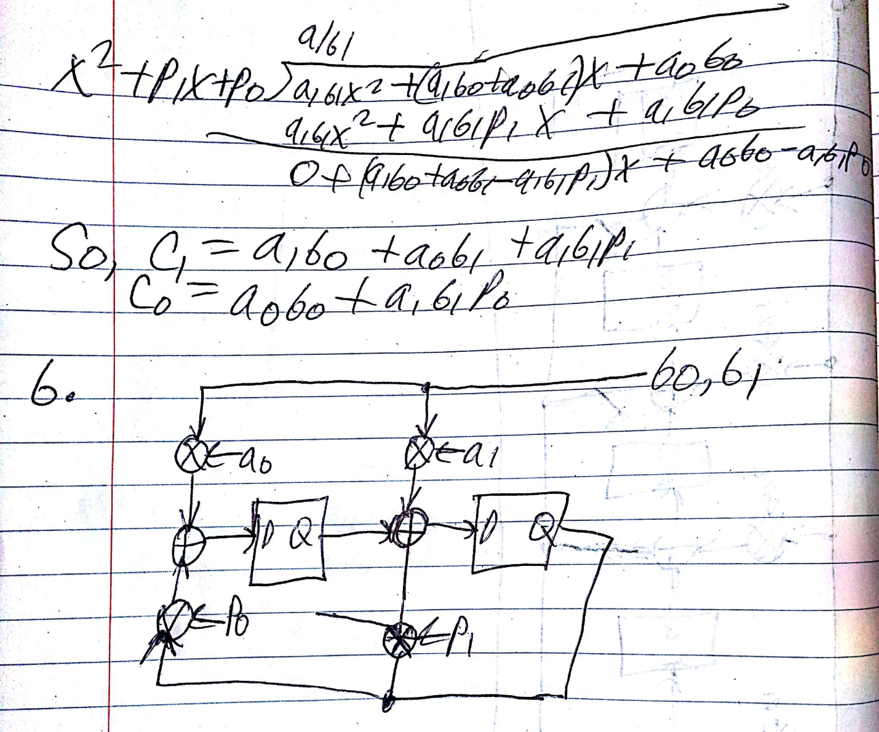  
8.

We use multiplication clocked at 50MHz.  
With this clock frequency, we have a 1/(50*106) = 20 ns clock period.  
To perform the Diffie-Hellman Key Exchange, we assume each side simultaneously generates their public key, sends the key to each other, and then determines a shared secret key from this. In order to generate their public key using their private key in GF(2593), this will take on average (2*2296) clock cycles, which would require (2*2296)*20ns = 4.9*1077 seconds or 1.36 hours, which seems extremely large.